North Warwickshire UKSPF Advisory Panel - Minutes
Wednesday 20 March 10am

Present: Cllr. D Wright (Chairperson), Cllr. H. Phillips, Cllr. Ridley, Cllr. Clews, Cllr. Gosling, Cllr. Jarvis (substitute for Cllr. Bell).
Steve Maxey, Becky Evans, Sally Roberts, Steph Wagstaff (all NWBC), William Tse (WCC), Jack Pritchard (Police), Lorraine Verrall (NWCA), Andy Hobbis (DWP), Kyra Norman (Beam), Aicha (Beam), Fiona (Beam), Jacky Chambers (Atherstone TC), Martin Short (Atherstone TC), Gwyn Short (Atherstone TC)

Apologies for Absence: Cllr. Bell, Mary Dunleavy (DWP), Sarah Newell (WCAVA), David Simkins (WCAVA)

Notes | Action
Allocation

The Panel were reminded that the overall funding allocation for North Warwickshire is:

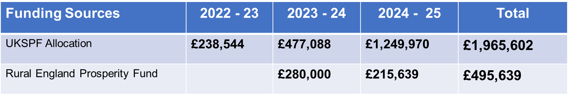
Matters Arising  Following the previous Panel, a decision was still sought regarding the People and Skills proposal from WCC.  WCC to be contacted to discuss an amended proposal. | SM / BE
Allocations to Date

Total allocations to date:

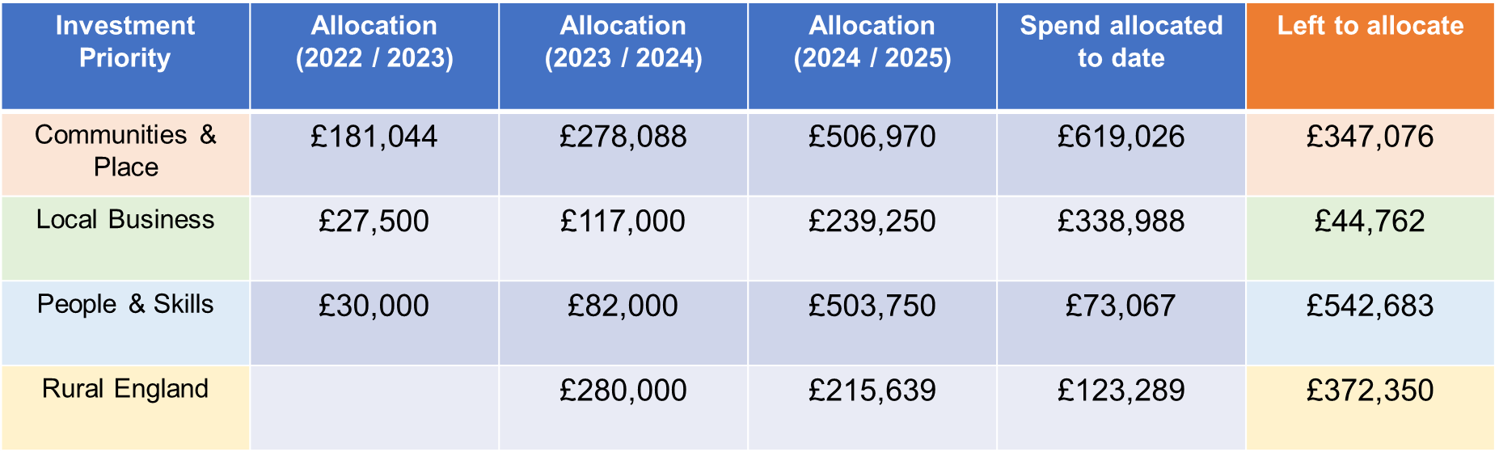

The cost of administrative support also comes from the core UKSPF funding.
Funding Requests and Decision Making

The following applications were received and concluded as shown:

Emergency Food Provision (We Care UK) | APPROVED
Laurel Garden Improvement to Outdoor Space (Laurel Gardens) | APPROVED subject to confirmation regarding opening hours
Central Atherstone Improvements (Atherstone Partnership) | APPROVED subject to asset audit
Feasibility Study to Improve Footpath Network and Promote Biodiversity (Atherstone Town Council) | APPROVED
Pond Dipping Area (Baxterley in Bloom) | APPROVED
Coleshill Scouts Camping Equipment (Coleshill Scout Group) | APPROVED
Hartshill Parkrun (Hartshill Academy) | APPROVED
Brendon Close Removal of Play Equipment (NWBC) | APP0ROVED
Inclusivity Work at Cole End Park Play Area | APPROVED
Warton Community Speed Watch (Warton Community Speed Watch) | APPROVED
North Warwickshire People and Skills (BEAM) | APPROVED
Automation of Product Line at LA Food (LA Food Distribution Ltd) | APPROVED
Tithe Barn Sign (Polesworth Parish Council) | APPROVED

Future Meeting Dates

19 June 10am Committee Room
18 September 10am Committee Room
11 December 10am Committee Room

