North Warwickshire UKSPF Advisory Panel - Minutes
Wednesday 21 February 10am

Present: Cllr. D Wright (Chairperson), Cllr. H. Phillips, Cllr. Ridley, Cllr. Clews, Cllr. Gosling, Cllr. Symonds
Steve Maxey, Becky Evans, Sally Roberts, Steph Wagstaff (all NWBC), Roger Minett (NWCA), Faye Winterburn (WCC), William Tse (WCC), Sarah Newell (WCAVA), Jane Coates (WCC), Jack Pritchard (Police)

Apologies for Absence: Cllr. Bell, Mary Dunleavy (DWP), Matthew Epps (WCC), Charles Barlow (WCC), Uju Okereke (WCC)

Notes | Action
Allocation

The Panel were reminded that the overall funding allocation for North Warwickshire is:

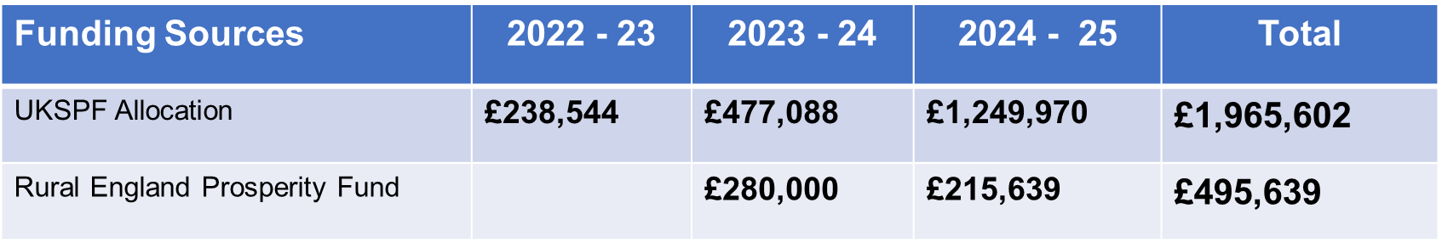
Allocations to Date

The funding for year 3 was open for consideration.

In previous meetings, the Panel had already agreed to support the following out of the year 3 allocation:

Business Support (£195k)
Town Centre Project Officer (£30,960)

Total allocations to date:

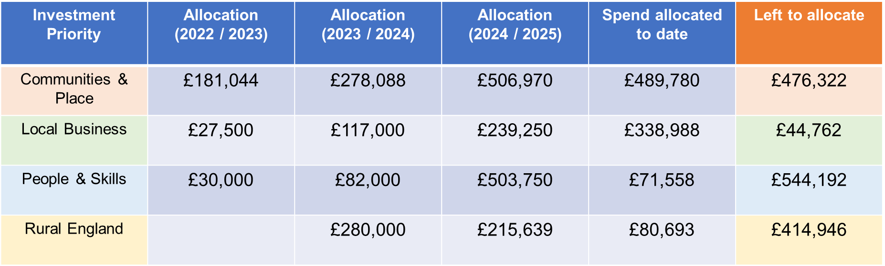

The cost of administrative support also comes from the core UKSPF funding.

Funding Requests and Decision Making

The following applications were received and concluded as shown:

Footfall Counter Licences (NWBC) | APPROVED
Additional Pre-school Play Equipment  (Nether Whitacre Parish Council) | APPROVED
Haunchwood Sports Junior FC Pavilion Refurbishment (Haunchwood Sports Junior Football Club) | APPROVED
Central Polesworth Improvement Plan  (Polesworth Partnership) | APPROVED
Atherstone Memory Café (Home Instead) | APPROVED
Big Day Out (NWBC) | APPROVED
Warwickshire County Council: People and Skills Offer | Request for an additional meeting for further discussion
Warwick Refugee ESL (English as a second language) (WIDE) | APP0ROVED
Doors & Window improvements and upgrades  (Middleton Hall Trust) | Request for clarification
Baxterley Recreation Ground accessibility  (NWBC) | APPROVED
Cole End Park path repairs (NWBC) | APPROVED

Future Meeting Dates

20 March 10am Committee Room
19 June 10am Committee Room
18 September 10am Committee Room
11 December 10am Committee Room

