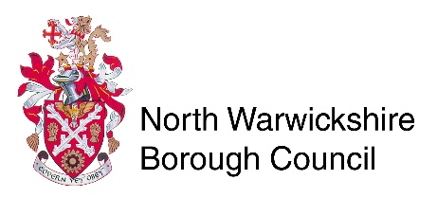
Central Services
North Warwickshire Borough Council
The Council House
South Street
Atherstone
CV9 1DE
Licensing Act 2003
Personal Licence Replacement

1. Your personal details

TITLE Please tick 

Mr Mrs Miss Ms Other (please state)

Full name
Contact Tel:
Mobile:

HOME ADDRESS

Reason for replacement licence

Sign

Date

Please note this form should be returned with your original personal licence (photo card and paper counterpart), 2 x photos (passport size), and a fee of £10.50 paid by card or cheques made payable to North Warwickshire Borough Council. If the application is to change name, proof of name change is also required.
Forms to be returned to:
Central Services
North Warwickshire Borough Council
South Street
Atherstone
CV9 1DE
Telephone – 01827 719217

A replacement licence will be issued in due course.
FAILURE TO NOTIFY THE LICENSING AUTHORITY OF CHANGE OF NAME OR ADDRESS IS AN OFFENCE UNDER SECTION 127 OF THE LICENSING ACT 2003.

