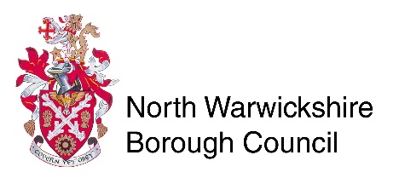
Central Services
North Warwickshire Borough Council
The Council House
South Street
Atherstone
CV9 1DE
Licensing Act 2003
Personal Licence Change of Name or Address

1. Your personal details

TITLE Please tick 

Mr Mrs Miss Ms Other (please state)

Full name

New name

Contact Tel:
Mobile:

PREVIOUS ADDRESS

NEW ADDRESS
Please note this form should be returned with your original personal licence (photo card and paper counter-part), 2 x photos (passport size) and a fee of £10.50 paid by card or cheques made payable to North Warwickshire Borough Council. If application is to change name, proof of name change also required.
Forms to be returned to:
Central Services
North Warwickshire Borough Council
South Street
Atherstone
CV9 1DE
Telephone – 01827 719217

An amended licence will be issued in due course.
FAILURE TO NOTIFY THE LICENSING AUTHORITY OF CHANGE OF NAME OR ADDRESS IS AN OFFENCE UNDER SECTION 127 OF THE LICENSING ACT 2003.

Sign

Date

