North Warwickshire UKSPF Advisory Panel - Minutes
Wednesday 11 December 10am

Present: Cllr. D Wright (Chairperson), Cllr. Bell, Cllr. Clews, Cllr. H. Phillips, Cllr. Ridley

Steve Maxey, Becky Evans, Sally Roberts (all NWBC), Lorraine Verrall (NWCA), Roger Minett (NWCA), Sarah Newell (WCAVA), Mary Dunleavy (DWP), Andi Gibbons (Warwickshire Police)

Apologies for Absence: Matthew Epps (WCC), William Tse (WCC)

Notes | Action
Overall Allocation

The Panel were reminded that the overall funding allocation for North Warwickshire is:

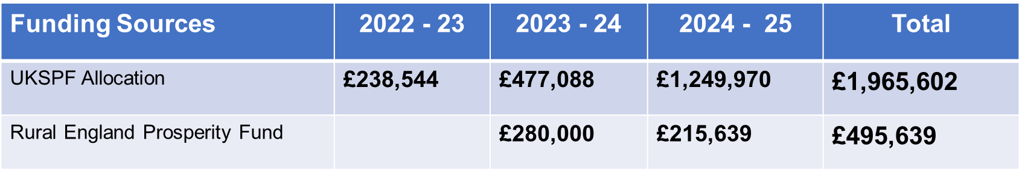
Allocations to Date

Total allocations to date:

 | Total allocation |  |  | Total left to allocate
 | 2022 / 23 | 2023 / 24 | 2024 / 25
Communities & Place | £181,044 | £278,088 | £506,970 | £24,929
Local Business | £27,500 | £117,000 | £239,250 | £5,233
People & Skills | £30,000 | £82,000 | £503,750 | £146,490
Rural England |  | £280,000 | £215,639 | £2,264

The cost of administrative support also comes from the core UKSPF funding.

Matter Arising

Since the Panel there has been confirmation that the funding in 2025 / 26 will be allocated to Warwickshire County Council:

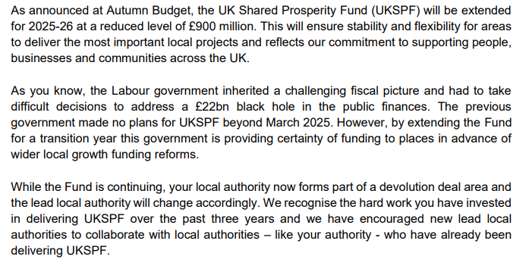
Warwickshire County Council will receive £5,275,931 for 2025 / 26 for the whole county.

Applications Received and Decisions

Open Hands (Open Hands Community CIC) | APPROVED
Drone Powerline Inspection Course and Certification Scheme (PQMS) | APPROVED
Volunteer It Yourself (Volunteer It Yourself) | APPROVED
Hercules | APPROVED

