North Warwickshire UKSPF Advisory Panel - Minutes
Thursday 13 June 10am

Present: Cllr. D Wright (Chairperson), Cllr. H. Phillips, Cllr. Ridley, Cllr. Clews, Cllr. Osbourne
Steve Maxey, Becky Evans, Sally Roberts, Rachel Stephens (all NWBC), William Tse (WCC), Sarah Newell (WCAVA)

Apologies for Absence: Cllr. Bell, Cllr. Gosling, Mary Dunleavy (DWP), Charles Barlow (WCC), Lorraine Verrall (NWCA), Roger Minett (NWCA),

Notes | Action
Allocation

The Panel were reminded that the overall funding allocation for North Warwickshire is:

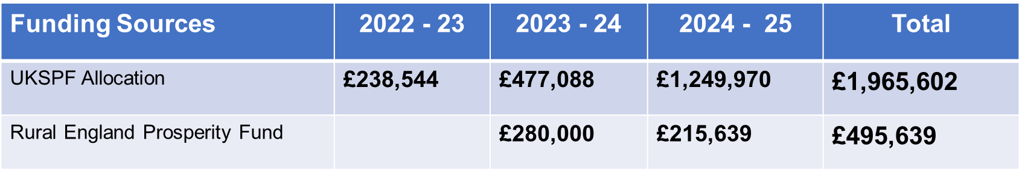
Allocations to Date

Total allocations to date:

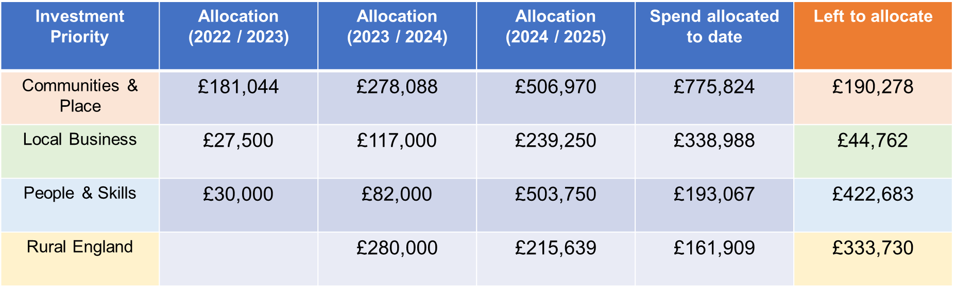

The cost of administrative support also comes from the core UKSPF funding.

Funding Requests and Decision Making

The following applications were received and concluded as shown:

Fillongley Changing Rooms (Fillongley Parish Council) | APPROVED
Central Coleshill Improvements (Coleshill Partnership) | APPROVED
Shustoke Play Area (Friends of Shustoke Park) | APPROVED
Sensory Garden (Oldbury Cottage Care Farm) | APPROVED
“Kick Start” (Next Generation) | REJECTED
Project EPC (NWBC) | APPROVED
Atherstone Sports Club Pitch and Clubhouse Improvements (Atherstone Sports Club) | APPROVED
IT Equipment (Oldbury Cottage Care Farm) | APP0ROVED
Central Polesworth Flood Measures (Polesworth Partnership) | APPROVED subject to clarification
Teenage Market Skills Workshop (NWBC) | APPROVED
People & Skills Offer (Hercules Construction Academy) | APPROVED
Automated packaging line for fresh and frozen chips (Edima Holdings Ltd) | APPROVED
Warton Village Hall Improvements (Warton Parish Council) | APPROVED
Access Improvements at Brett’s Hall Recreation Ground (NWBC) | APPROVED
Accessibility Improvements to Green Spaces (NWBC) | APPROVED

Future Meeting Dates

18 September 10am Committee Room
11 December 10am Committee Room

